Table of Contents

1) Prerequisites and Setup: 1

2) Step 1: Create a Snowflake Account 1

3) Step 2: Create a Dataiku Account 2

4) Step 3: Setting Up the Snowflake Connection in Dataiku 2

5) Step 4: Testing and Finalizing the Connection 4

6) Step 5: Creating a Project in Dataiku 5

7) Step 6: Importing Data from Snowflake into Dataiku 6

Dataiku-Snowflake Connection

1. Prerequisites and Setup:  
   This connection process does not require any advanced skills. The only essential prerequisite is having a Snowflake account. If you do not have one, you can sign up for a free 30-day trial. For users already using Dataiku Online, you can connect to your existing Snowflake account.

## Step 1: Create a Snowflake Account

Start by signing up for Snowflake’s 30-day free trial, which includes $400 worth of free usage.  
Visit [snowflake.com](https://signup.snowflake.com/) to create your account. If you already have an account, simply log in. Once signed up, enter the necessary details. On the following page,

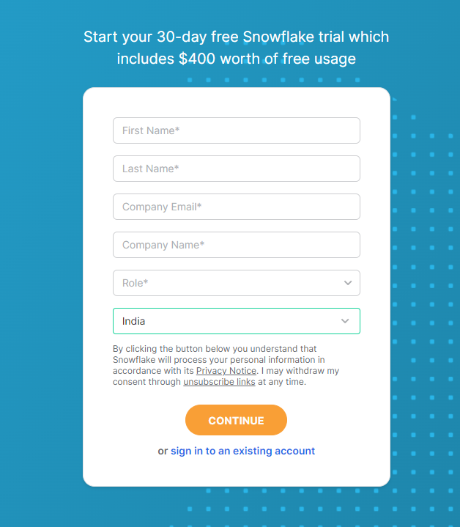

select the preferred Snowflake edition and cloud provider.

## Step 2: Create a Dataiku Account

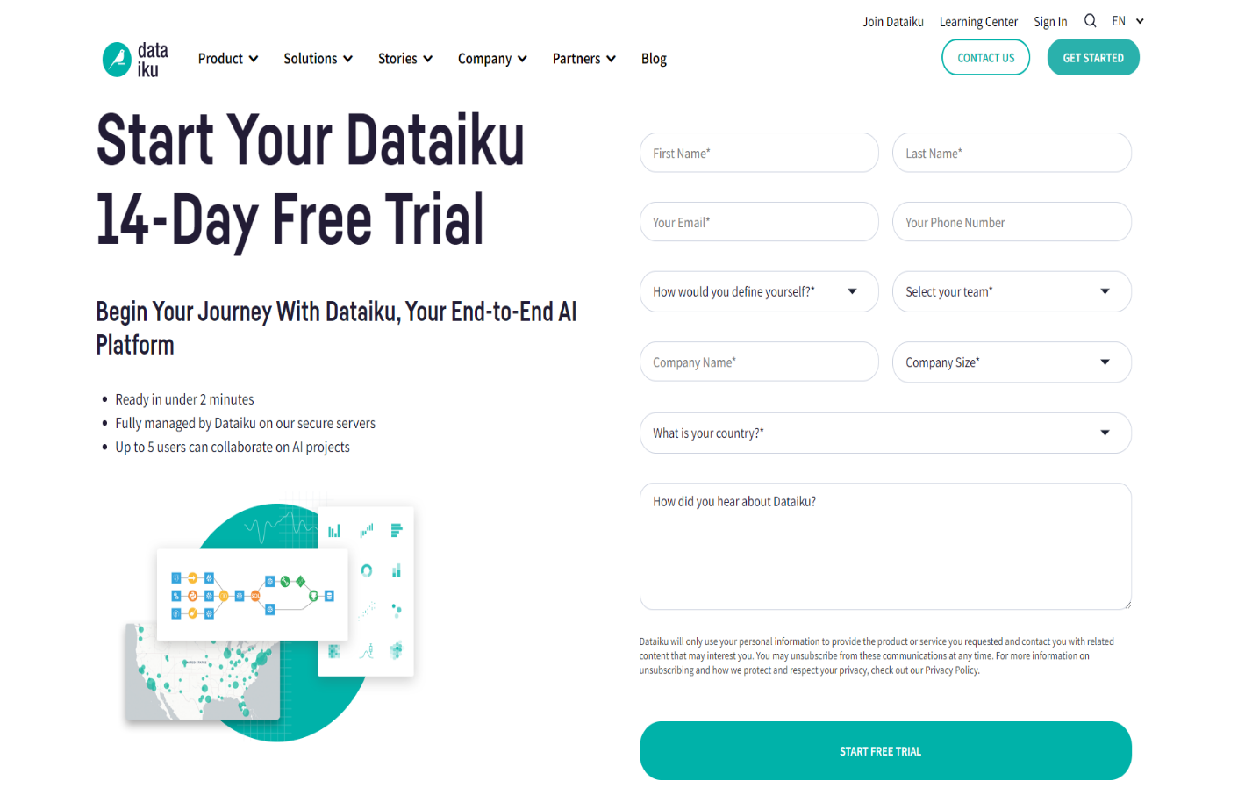To begin, sign up for Dataiku’s 14-day free trial by visiting [dataiku.com](https://www.dataiku.com/product/get-started/).  
Enter the required information and follow the steps to activate your free trial.

## Step 3: Setting Up the Snowflake Connection in Dataiku

1. **Open Dataiku:**  
   From the launch pad, select the “Connections” tab and click on “Add a New Connection.”

1. 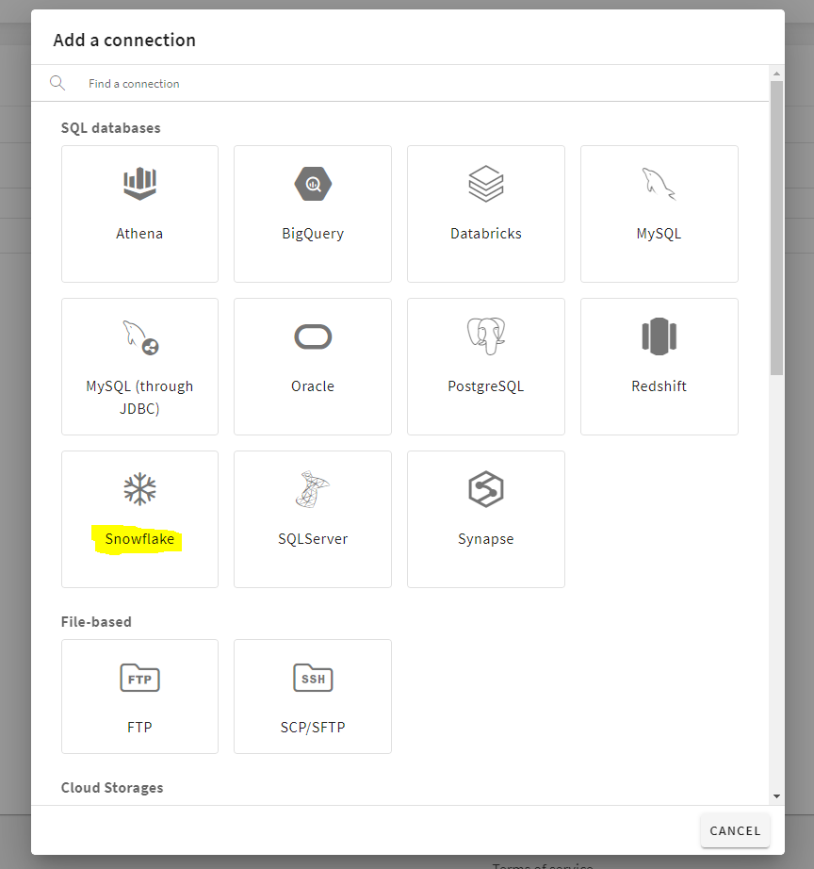**Choose Snowflake as the Connection Type:**  
   In the "SQL Databases" section, select "Snowflake."
2. **Configure the Snowflake Host:** In the “Host” section, you will need to enter the URL for your Snowflake instance.  
   For example, if your Snowflake URL is:  
   **https://app.snowflake.com/sfjiqas/pl77957/#/homepage**,  
   you would extract only the portion between https://app.snowflake.com/ and #/homepage, which in this case is “ sfjiqas-pl77957 “.  
   Then, append .snowflakecomputing.com to it.  
   The final host URL will be: “ sfjiqas-pl77957.snowflakecomputing.com. ”

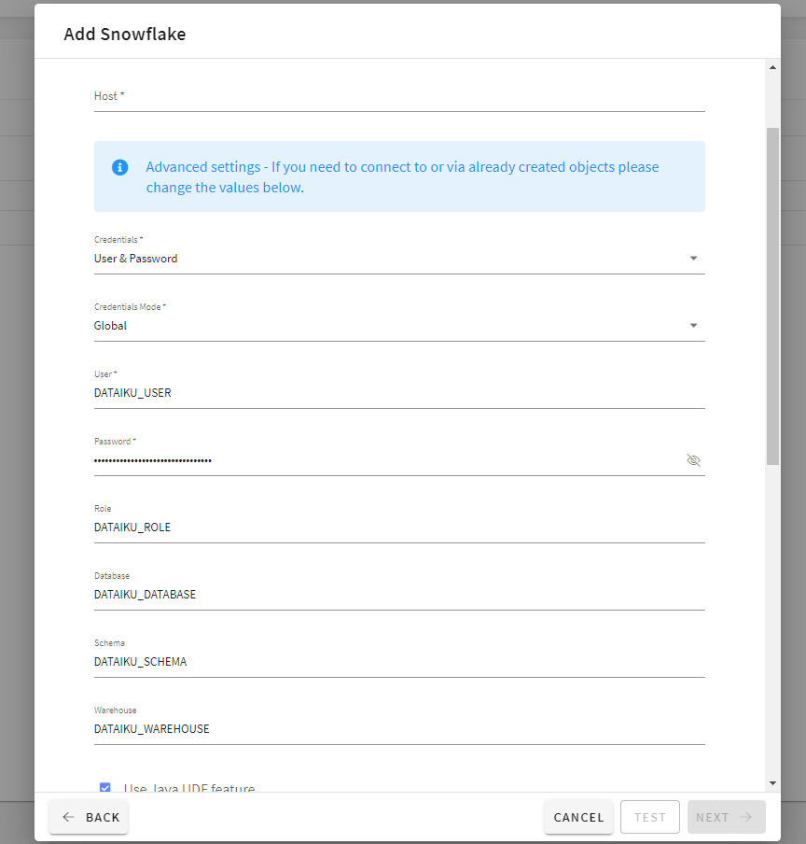

1. **Run the Auto-Generated SQL Commands:**  
   After entering the host URL, click "Next." Dataiku will generate SQL commands that need to be executed in your Snowflake account. Run these commands in Snowflake.

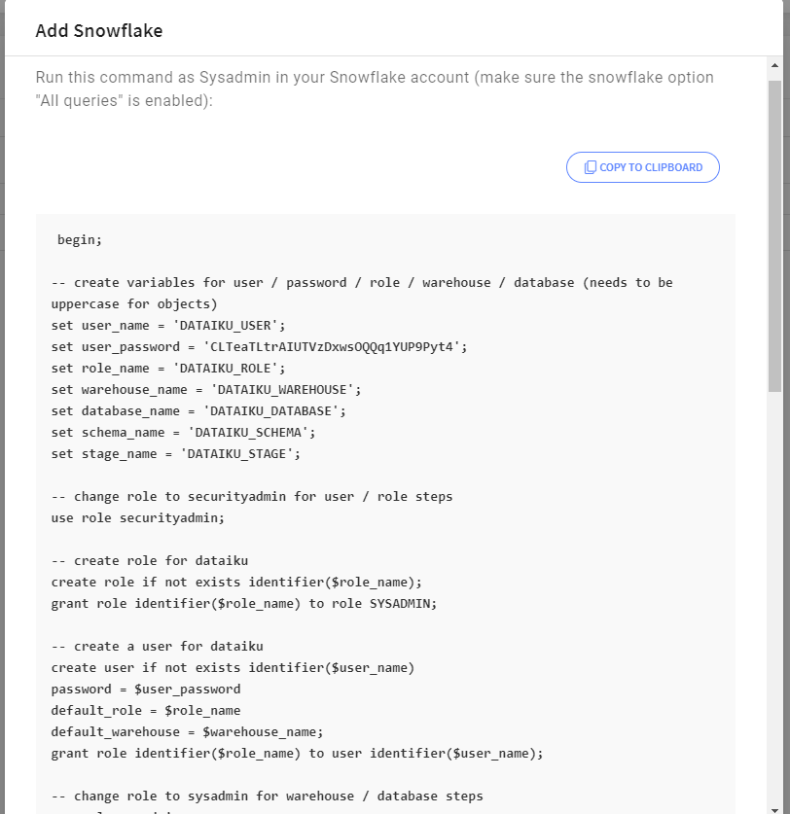

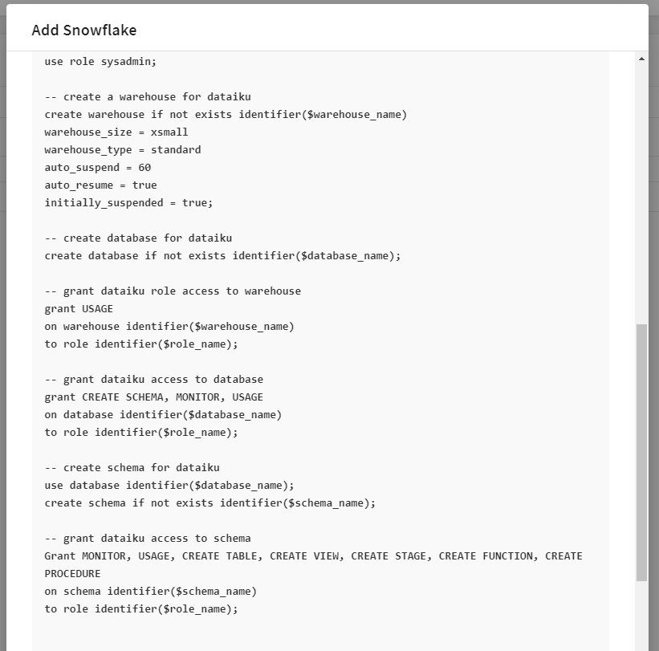

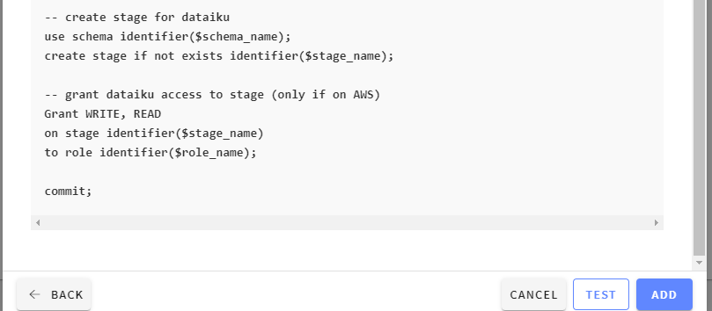

## Step 4: Testing and Finalizing the Connection

1. **Test the Connection:**  
   After successfully running the SQL commands in Snowflake, return to Dataiku and click "Test" to ensure that the connection is working correctly.
2. **Add the Connection:**  
   Once the test is successful, click "Add" to finalize the Snowflake connection within Dataiku.
3. **Access Dataiku Launchpad:**  
   After the Snowflake connection is established, go to the Dataiku Launchpad and click on "Open Instance" to be redirected to the Dataiku homepage.

## Step 5: Creating a Project in Dataiku

1. **Create a New Project:**  
   From the Dataiku homepage, click on "New Project."

1. **Select Blank Project:**  
   Choose "Blank Project" and name the project as per your preference.

1. **Import Your Dataset:**  
   Once your project is created, click on "Import Your First Dataset" and select "Snowflake" from the SQL tab to start working with your Snowflake data within Dataiku.

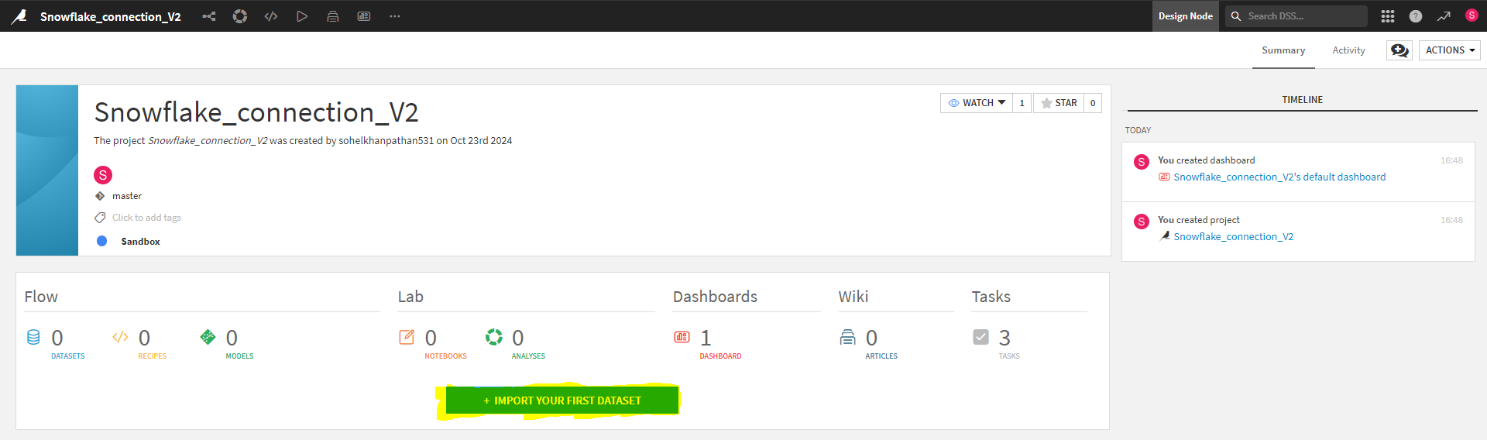

## Step 6: Importing Data from Snowflake into Dataiku

1. **Add a New Dataset Name:**  
   After selecting "Snowflake" as the data source, enter a name for your new dataset.
2. **Retrieve Table List:**  
   Click on the "Get Table List" button to fetch the list of available tables from your Snowflake database.
3. **Select Your Table:**  
   From the table list, choose the desired table you wish to work with. After selecting the table, click "Test Table" to ensure the connection to the table is successful.
4. **Create the Dataset:**  
   Once the table test is successful, click "Create" to officially add the dataset to your Dataiku project. You will now be able to view and interact with your dataset.

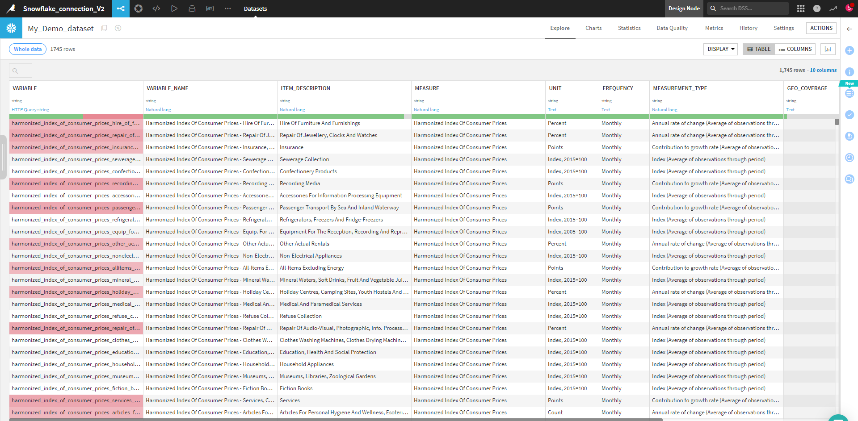

Congratulations!

You have successfully connected Snowflake to Dataiku and imported your data, allowing you to begin working with it in your Dataiku project.